Laura Sebastian LMT ~ Massage Therapy Intake Form
Name:_______________________________________________________Cell Phone:____________________________________
Address:____________________________________________________City:_____________________State:____Zip:__________
Email:_______________________________________________Occupation:___________________________________________
DOB:______________ Emergency Contact Name and Phone Number: ________________________________________________
Medical Information  Are you taking any medications? Yes No  - If yes, please list  Are you currently pregnant? Yes No  - If yes, how long?  - Any high-risk factors?  Do you suffer from chronic pain? Yes No  -If yes please explain  -What makes it better?  Have you had any major injuries or surgeries? Yes No  -If yes, please list what/when  Do you have any allergies? -please list  Please indicate any condition you have had in the past or currently have:  Headaches/migraines Jaw Pain/TMJ  Arthritis Tendonitis  Skin Conditions Diabetes  High/Low BP Herniated/bulging disc  Cancer Edema  Varicose veins Sleep difficulties  Fibromyalgia Anxiety  Sprains/Strains Numbness |  | Massage Information  Have you had professional massage before? Yes No  -If yes, how long ago was your last massage?  What is your major area of concern?  How long have you had this issue?  What are your goals and what type of massage are you seeking? (Circle all that apply)  Relaxation Stress Reduction Pain Reduction  Gentle pressure Medium pressure Deep pressure  Are there areas you would like focused on, and more time spent on? If so, where?  Are there areas you would like NOT massaged?  (For example, feet, face, head, abdomen, etc.)  Are you sensitive to any fragrances? Yes No  If yes, which ones?  Please circle any areas of discomfort  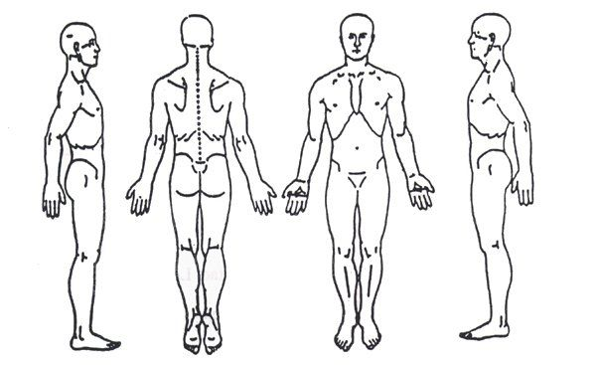
By signing below you agree to the following: I have completed this form to the best of my ability and knowledge and agree to inform my therapist if any of the above information changes at any time. I understand massage therapy is not a substitute for medical care. If I experience any pain or discomfort, I will immediately communicate this to the therapist so the treatment can be adjusted.
Client Signature________________________________________________________Date________________________

